* **What is the average attendance for any given club for the last season or for this season?**

match(from:club)-[r:played]->(to:match) return from.name as ClubName,avg(r.attendance) as AverageAttendance

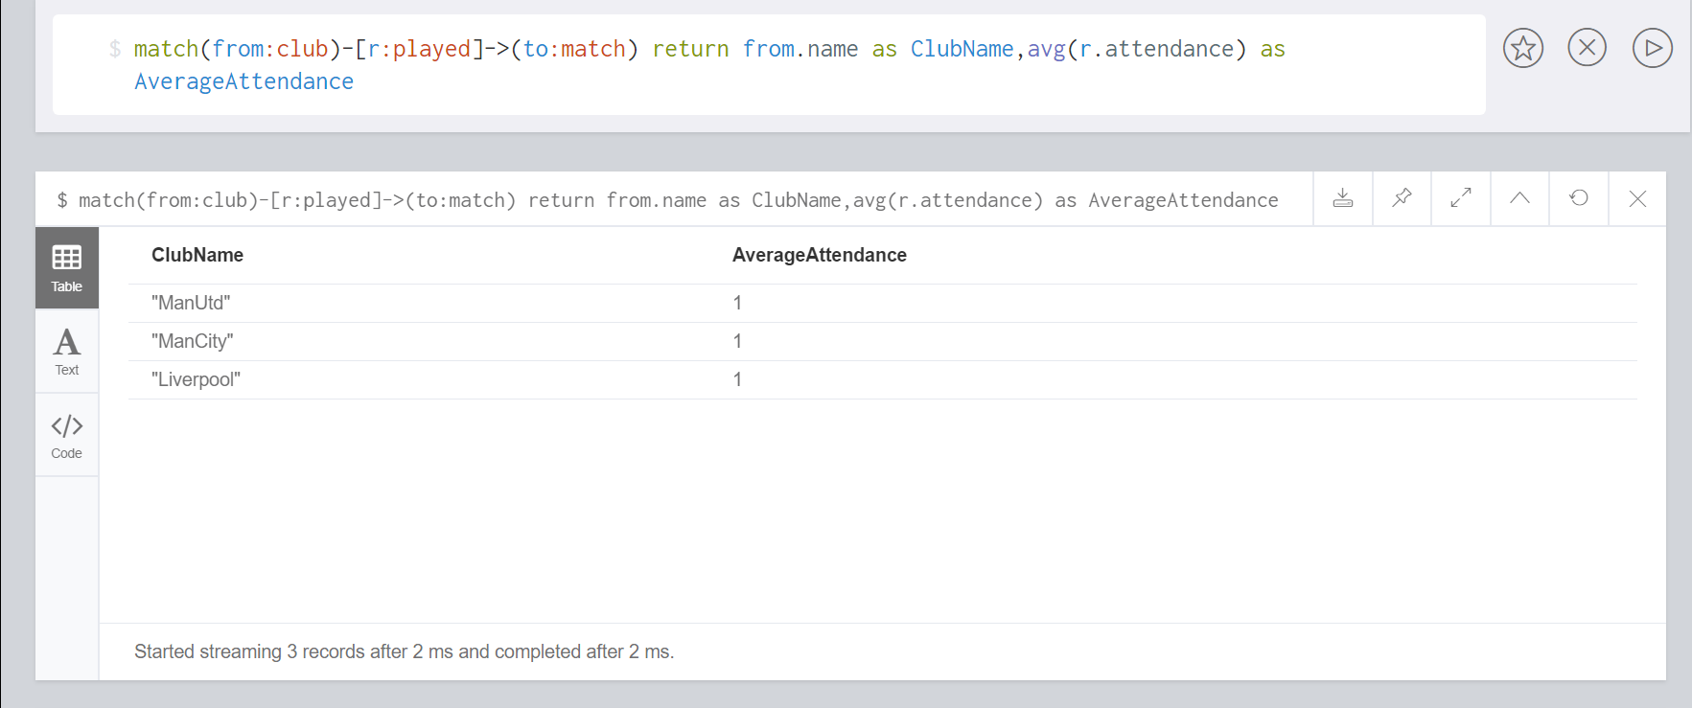

* **How many clean sheets has the given club “Club-name” kept in the current season?**

match(from:club)-[r:played]->(to:match) return from.name as ClubName,sum(r.cleansheet) as CleanSheets

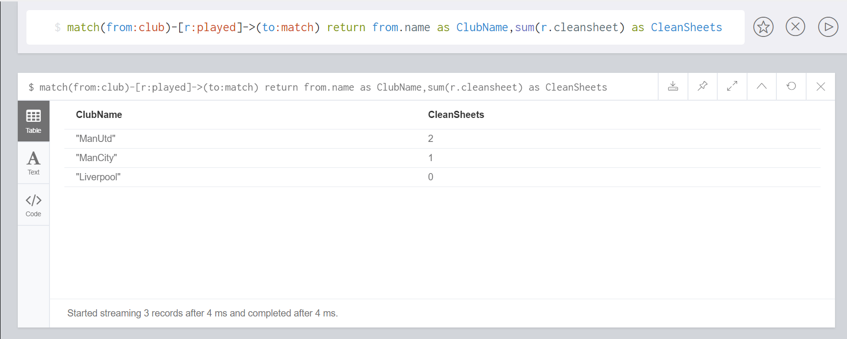

* **What is the transfer value (market value development) of a given player “Player-name” , This query should return name of the player, age of the player, each year market value and the club with which is the player is currently playing for**

match(from:player{name:"Marcos Rojo"})-[r:valuedAt]->(to:TransferValue) return from.name as PlayerName,from.age as Age,from.clubname as CurrentClub,r.marketvalue201718 as MarketValue2015to2016inMillion,r.marketvalue201617 as MarketValue2016to2017inMillion,r.marketvalue201718 as CurrentMarketValueinMillion

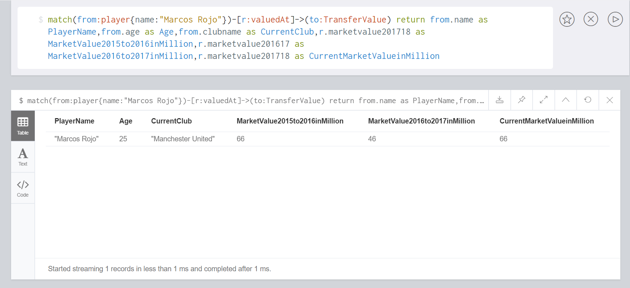

* **What is the weekly wage bill of the current squad for a given club “Club name”?**

match(from:club{name:"Liverpool"})-[r:owns]->(to:player)-[rr:valuedAt]->(too:TransferValue) return sum(rr.marketvalue201718)/40 as WeeklyWageBillingInMillion

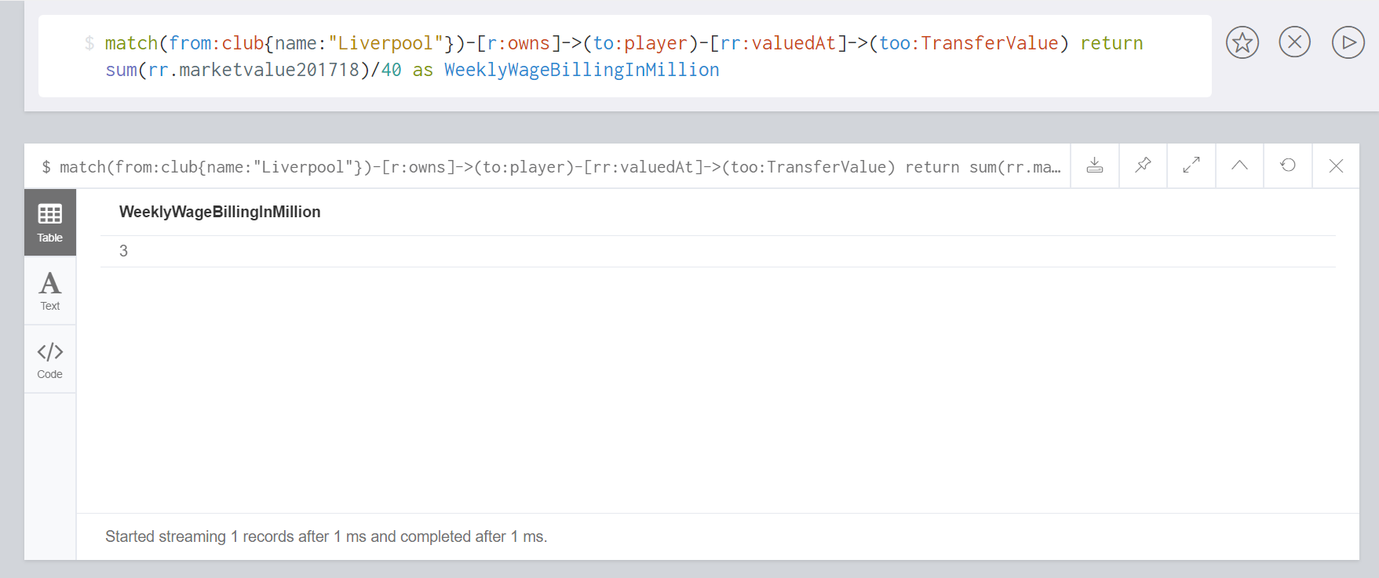

* **How many times was given manager awarded the manager of the month awards?**

match(from:club)-[r:managedby{name:"Mourihno"}]->(to:manager) return to.name as ManagerName,from.name as ClubName,r.awardcount as ManagerOfTheMonthAwards

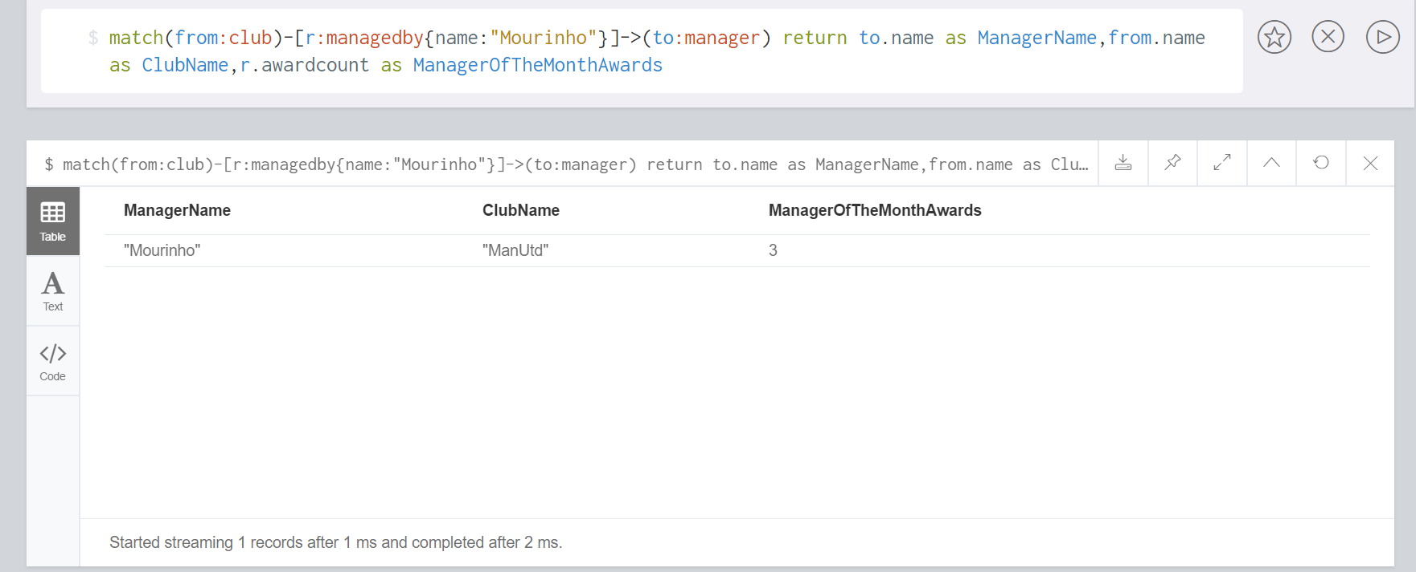

* **How many yellow/red cards has a player been fined till date?**

match(from:player)-[r:playedin]->(to:match) return from.name as PlayerName,from.clubname as ClubName,sum(r.yellowcard) as YellowCards,sum(r.redcard) as RedCards order by ClubName

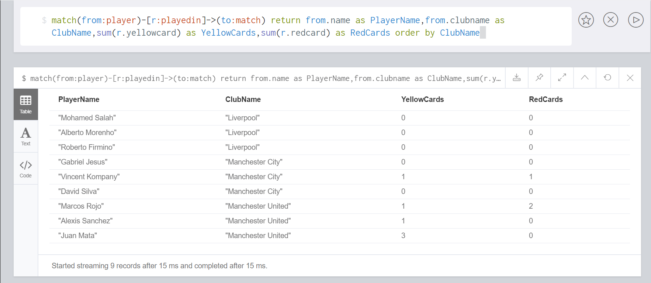

* **What are the stats for a given club for the last five matches?**

match(from:club)-[r:played]->(to:match)<-[pi:playedin]-(p:player) return distinct to.name as Match,from.name as ClubName,r.goal as GoalsScored,r.cleansheet as CleanSheets,r.possession as BallPossession,sum(pi.redcard) as RedCards,sum(pi.yellowcard) as YellowCards order by ClubName

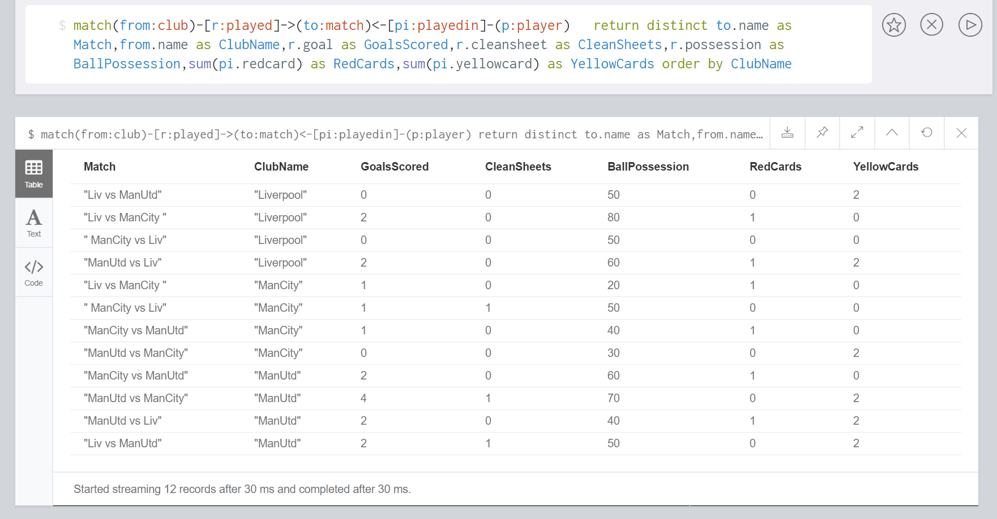

* **Which player has made the most number of assists till date?**

match(from:club)-[r:owns]-(to:player)-[rr:playedin]->(too:match) return to.name as PlayerName,to.clubname as ClubName,sum(rr.assists) as NumberOfAssists order by NumberOfAssists desc

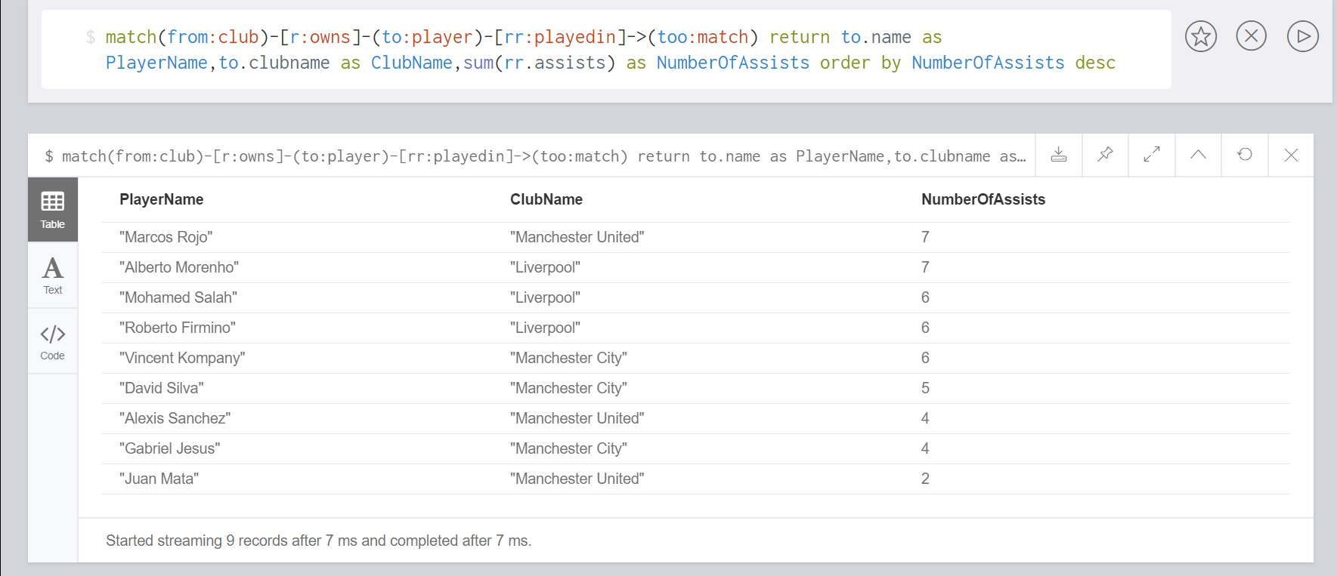

* **What is the average possession kept by a club?**

match(from:club)-[r:played]->(to:match) return from.name as ClubName,avg(r.possession) as AverageBallPossession order by AverageBallPossession desc

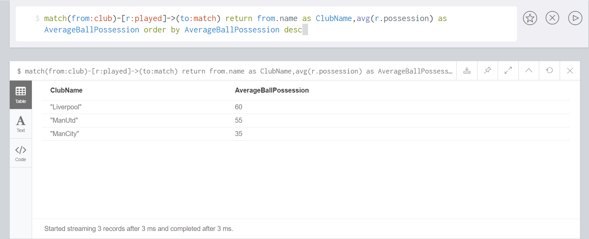

* **Calculate the number of minutes played by a player till date?**

match(from:player)-[r:playedin]->(to:match) return from.name as PlayerName,from.clubname as ClubName,sum(r.minutesplayed) as TotalMinutesPlayed order by ClubName

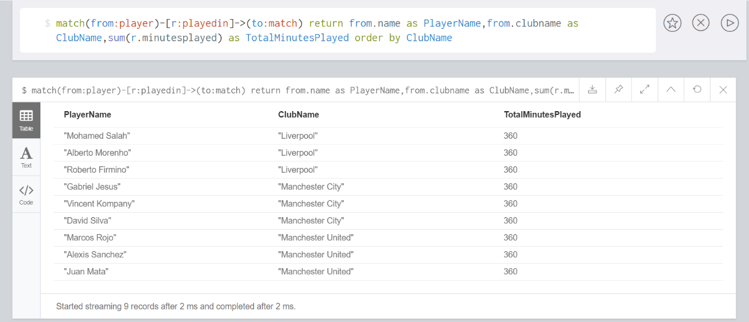

* **How many times has a player received the MotM(Man of the Match) award?**

match(from:player)-[r:playedin]->(to:match) return from.name as PlayerName,from.clubname as ClubName,sum(r.motm) as ManOfTheMatchAwards order by ManOfTheMatchAwards desc

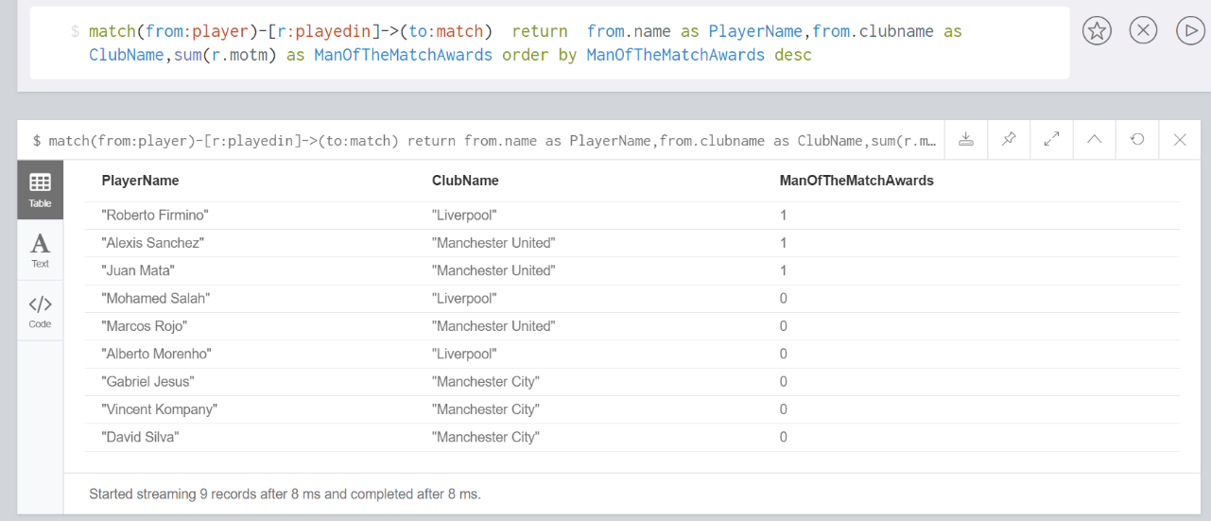

* **For which all positions did a given player play for this season? For example, P. Lahm can play as a Right Back, Center Back, or as a Midfielder. So considering these possibilities, during the announcing of lineups or during substitution a player can be assigned a position?**

match(from:player)-[r:playedin]->(to:match) return from.name as PlayerName,from.clubname as ClubName,from.possiblepositions as PossiblePositions,r.positionplayed as PositionPlayed,to.name as Match order by PlayerName

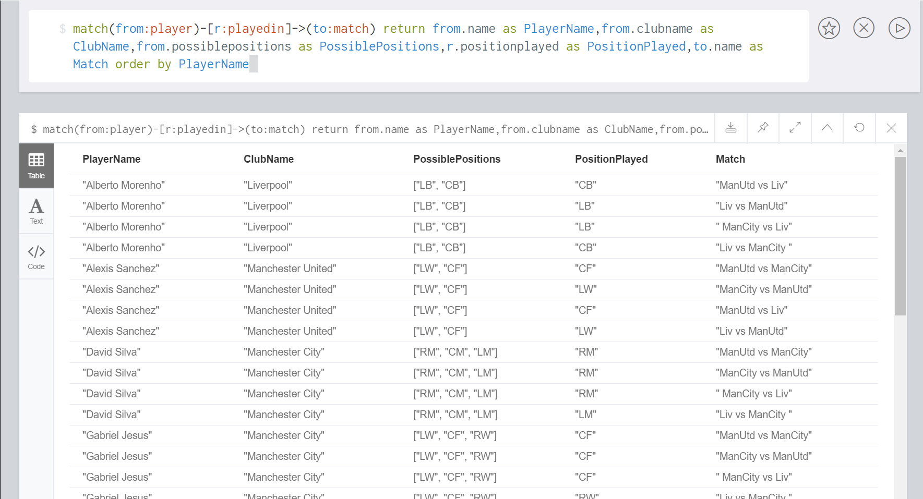

* **Which footballing-agent represents the maximum number of players in the given league? For example, Jorge Mendes is a super agent who represents various top players, such as C. Ronaldo, D. Costa, David de Gea.**

match (n:player) return max(n.agent) as RepresentsMaxPlayers

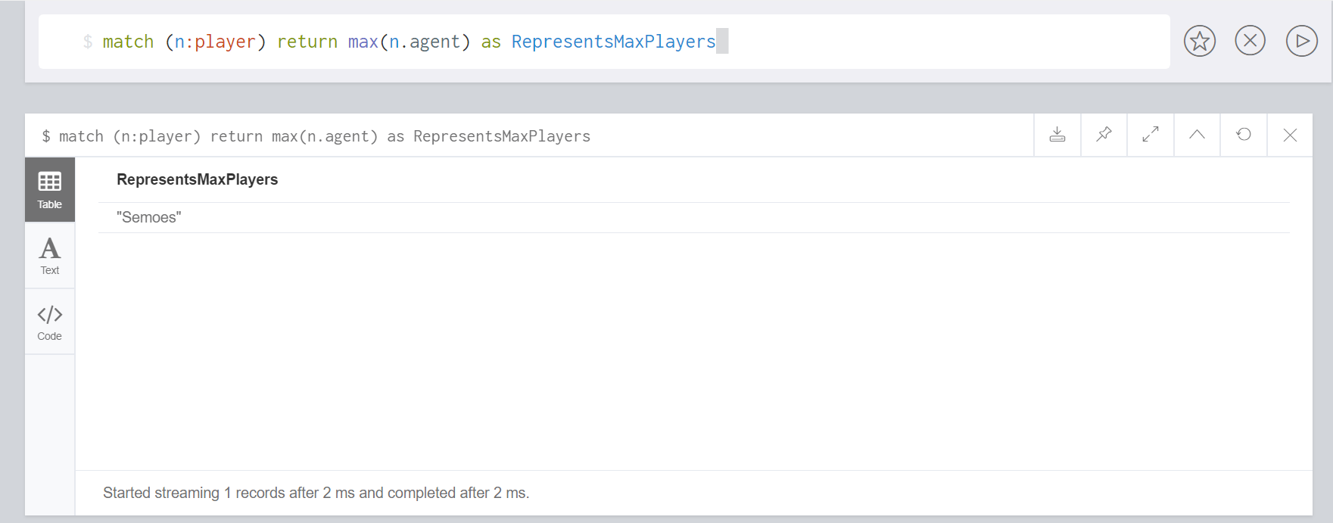

* **Based on the performance metrics captured by your data model can you calculate the Best Team of the Week as well as the Worst team of the week?**

Best Club:

match(from:club)-[r:played{weekid:1}]->(to:match)<-[pi:playedin]-(p:player) return from.name as BestClubOfTheWeek, sum((r.cleansheet*8)+(r.goal*10)+(r.possession*3)-(pi.redcard*10)-(pi.yellowcard*5)) as PerformanceMetrics order by PerformanceMetrics desc limit 1

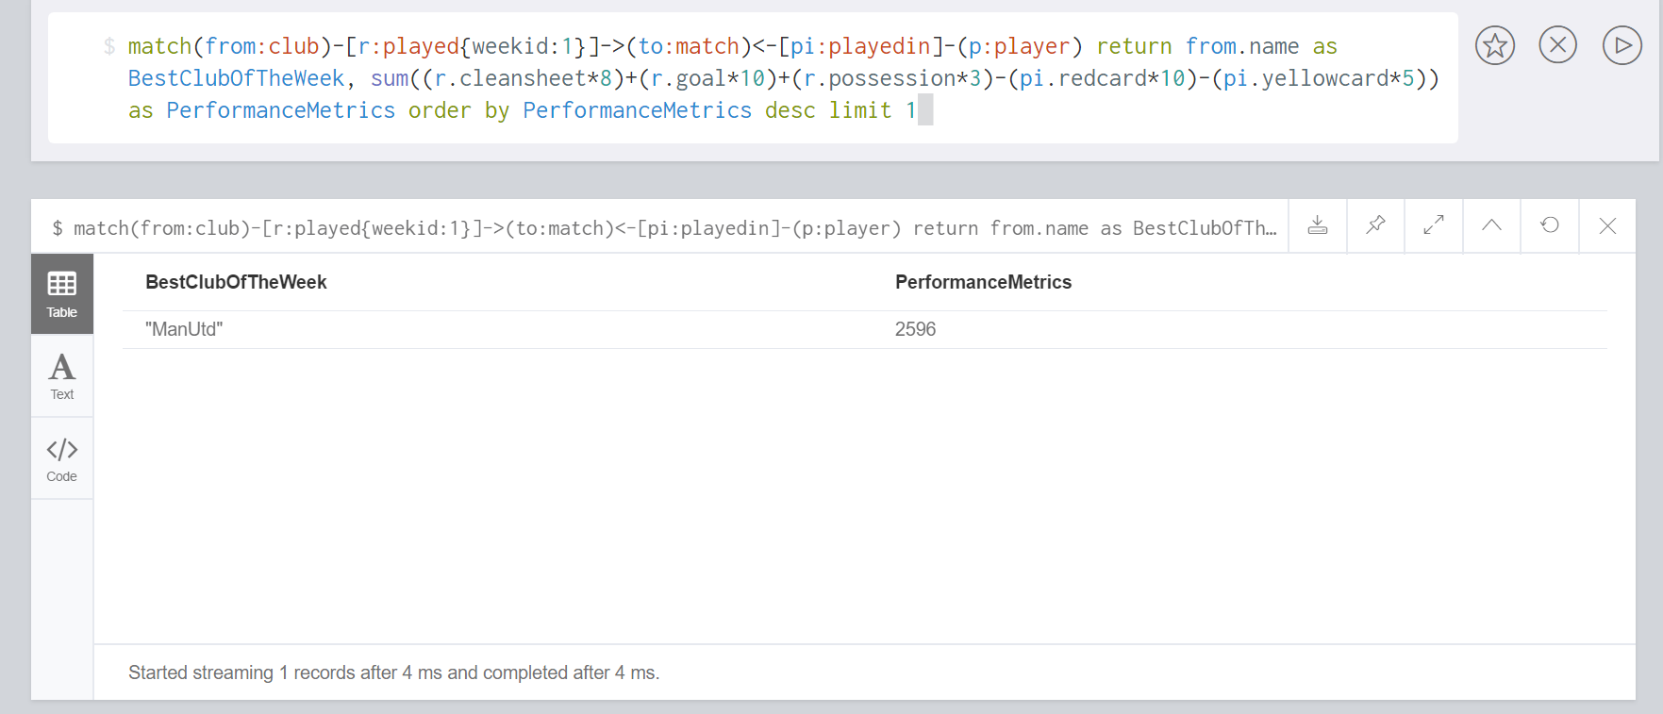

WorstClub:

match(from:club)-[r:played{weekid:1}]->(to:match)<-[pi:playedin]-(p:player) return from.name as WorstClubOfTheWeek, sum((r.cleansheet*8)+(r.goal*10)+(r.possession*3)-(pi.redcard*10)-(pi.yellowcard*5)) as PerformanceMetrics order by PerformanceMetrics limit 1

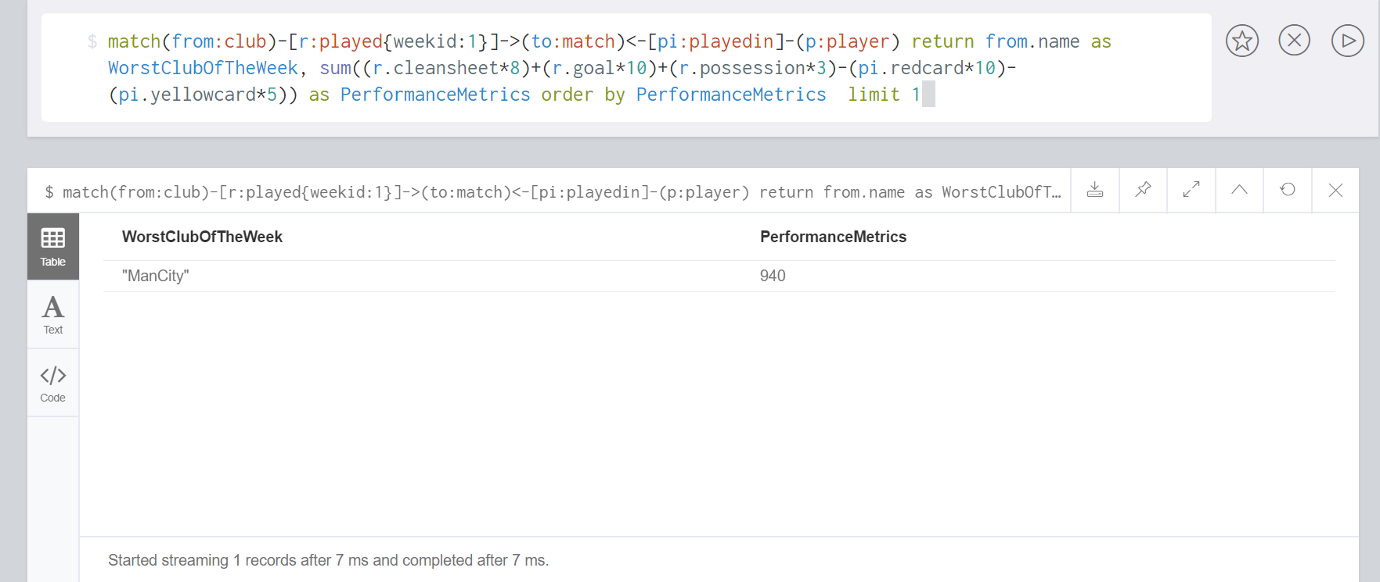

**Additional Queries**

* + Points Table:

match(from:club)-[r:played]->(to:match) return from.name as Club, count(r.attendance) as Played,sum(r.win) as Won,sum(r.loss) as Lost,sum(r.draw) as Drawn,((sum(r.win)*3)+sum(r.draw)*1) as Points order by Points desc

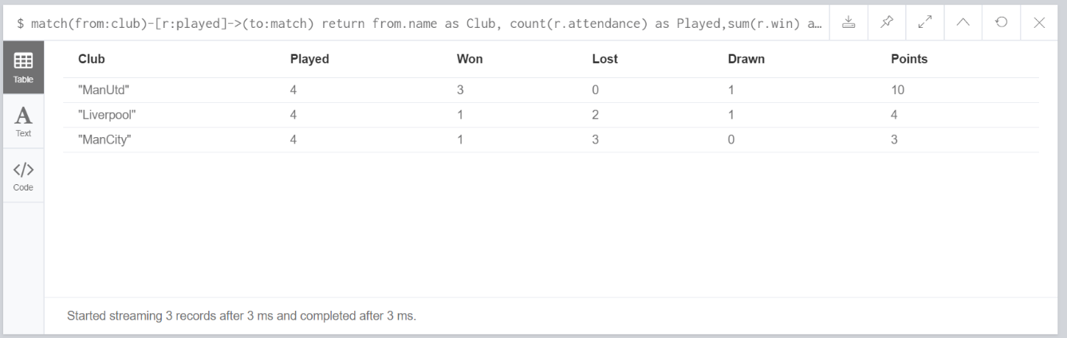

* + player with highest current value

match(from:player)-[r:valuedAt]->(to:TransferValue) return from.name as Player,from.clubname as Club,r.marketvalue201718 as MarketValueinMillion order by MarketValueinMillion desc limit 3

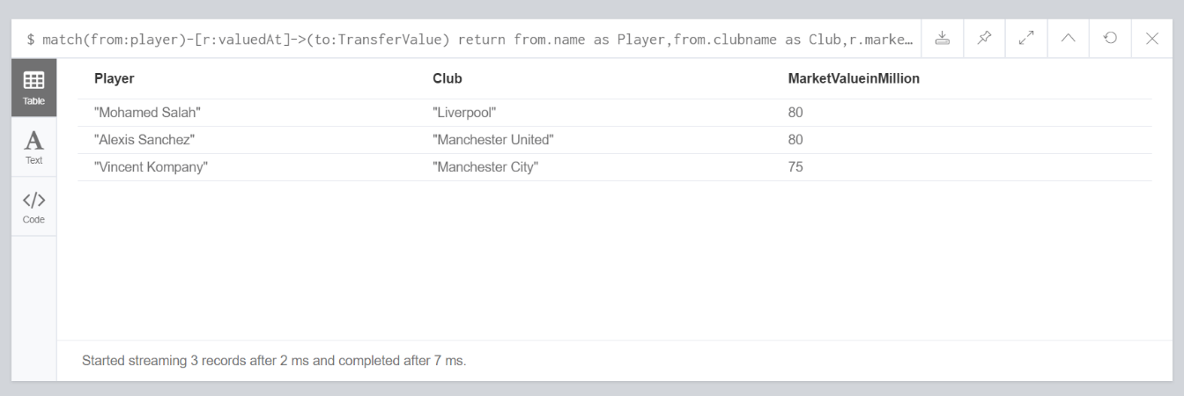

* + Top 5 goal scorers for the season:

match (from:player )-[r:playedin]->(to:match) return from.name as Player,sum(r.goals)

as Goals order by Goals desc limit 5

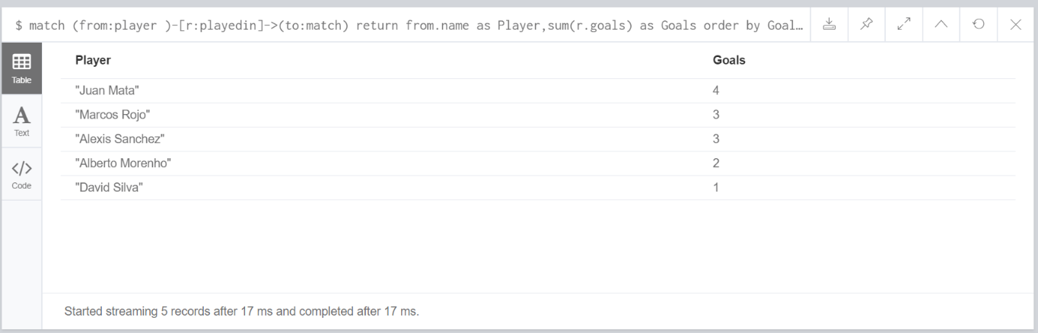

* + In which matches has a striker not scored a goal

match(from:player {Position:"Striker"})-[r:playedin]->(to:match)

where r.goals = 0 return from.name as StrikerName, to.name as Match

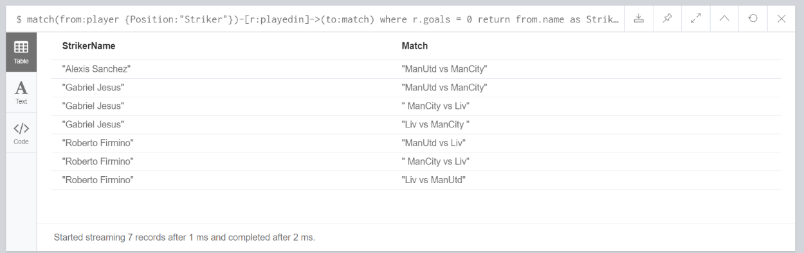

* + Players with most number of fouls

